

MATES Computer Science

**Senior Capstone Project Bi-Weekly Progress Report**

| Project Title | Journal Time! |
| --- | --- |
| Team Members | Shayne Lada, Ava McNabb, Lauren McNaboe |
| Dates Covered by Report | 5/06/24 - 5/17/24 |
| Link to Github | <https://github.com/code-shayne/journal-time-/tree/main> |
| Link to Website | https://code-shayne.github.io/journal-time-/index.html |

# **Summary of Project**

Journal Time! is a web app that allows users to journal and store entries online. The web app would provide prompts or free-journaling options and save all entries to unique user accounts. Users can also track emotions by indicating what they are feeling at the time of journaling. After each entry the user will receive a certain number of points or currency, incentivising journaling. The points can be used to buy accessories within the website such as different prompt packages, website themes, or journaling pets. The journaling pets would be avatars that live on the interface and encourage the user to journal and provide motivational messages. Points could also be used to customize and feed/play with pets. Users can track their journaling progress and view graphs and summaries of their emotions in a separate space on the web app. Email notifications can be scheduled to remind the user to journal or sent if the account hasn’t been used for 2 weeks. This project will encourage journaling, which is a useful practice for mental health and wellbeing. It will also make the process more accessible and fun for the users.

1. Summary of Progress this Period

Once again, we worked on smaller things as we await the SQL database. Shayne and Lauren both worked on shop items, with Shayne creating pages where the user can actually buy the item. Shayne also added a popup that will add crystals to a user's total crystal count. Lauren worked on converting the website to be mobile friendly, so you can journal on the go.

# **Detailed Progress this Period, separated by Team Member**

Lauren -

* prompts: I used ChatGPT to create more prompts, including a story package and a goal setting package. I’m very glad we formatted these as JSON in the JavaScript because it makes it 10x easier to add more and change what you already have instead of reading in a file or a database that stores them all
* updated the readme: Not super important, but I followed the code from the projects from last year, and now our readme has way more information in a nicely organized manner!

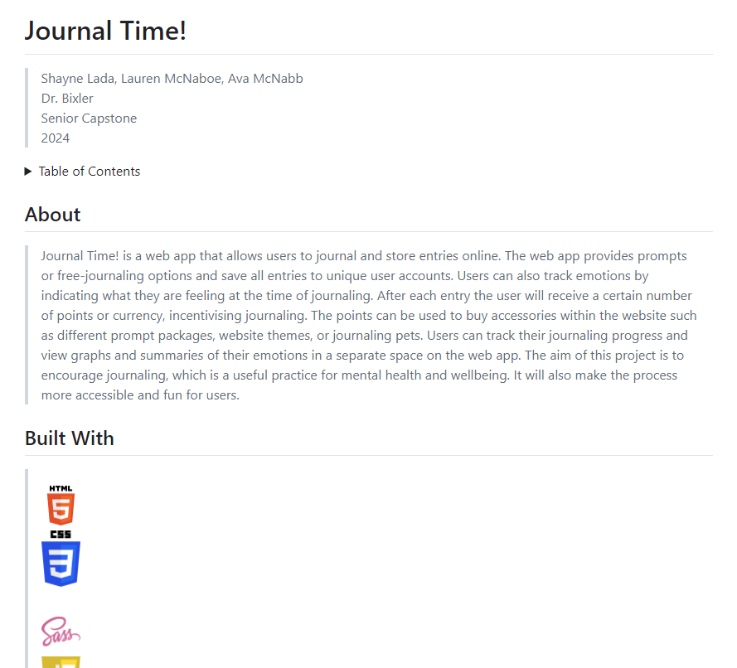

* making the website mobile friendly:
  + styling the elements on the page: Before, when you opened the website on a phone, everything was stretched downwards and it's really hard to see everything and click on things. What I’ve been trying to do (and it hasn’t gone super well) is resize everything when the screen is less than a certain width. Even after changing the widths and heights to percentages, nothing is changing
  + 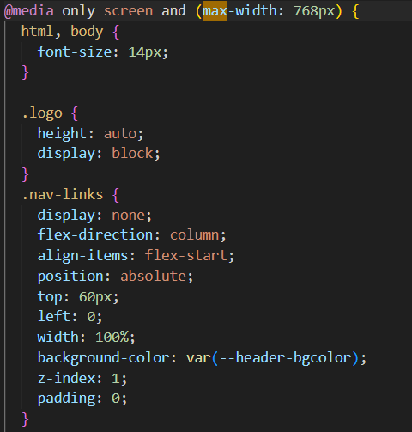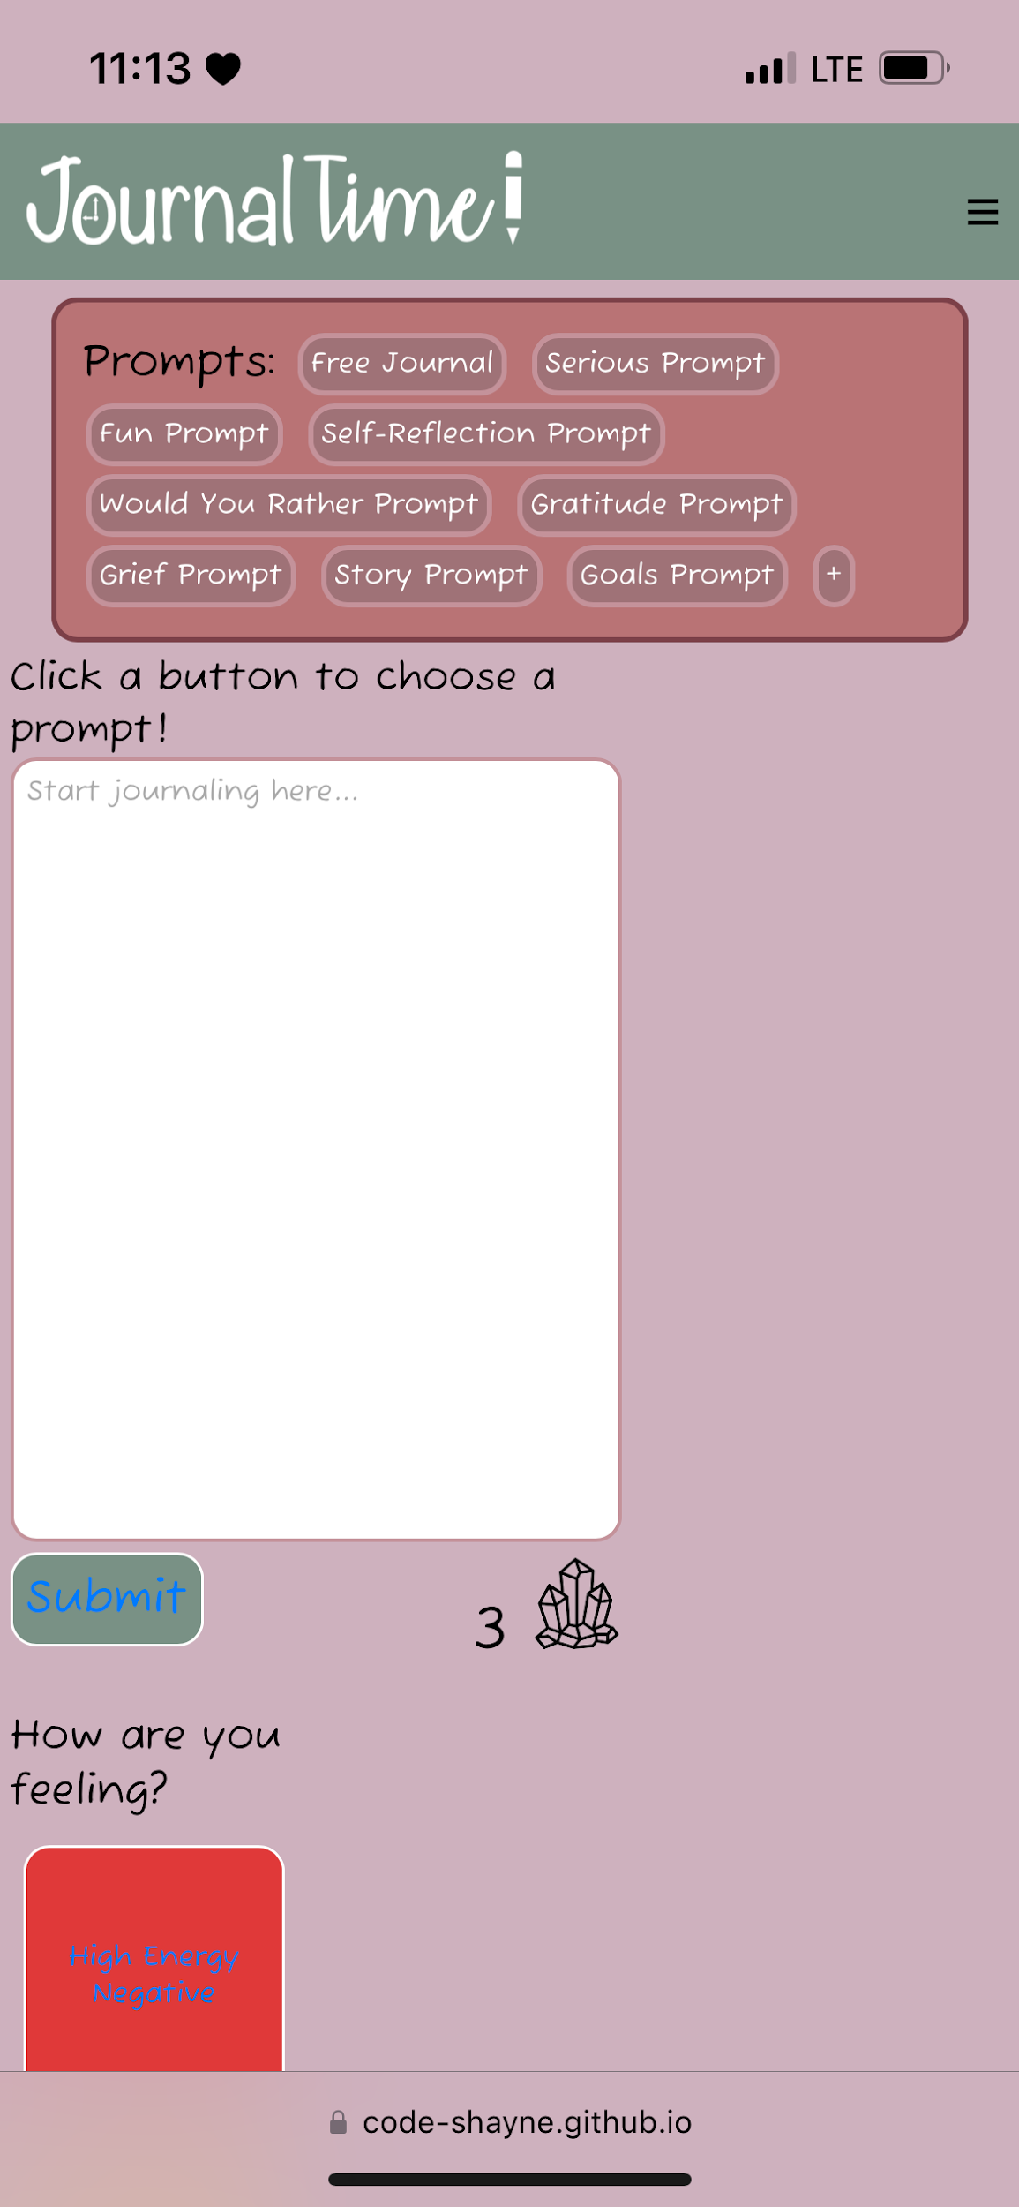
  + making the menu more accessible: on mobile, the buttons in the header would come down into the screen and be in the way of the functionality of the pages. I made a hamburger menu that allows users to click through the pages after clicking on the drop down.
    - issues: when I made the hamburger menu show up on each page, it got rid of the theming, since I had to move the <script src="js/index.js"></script> below the function that does the event listener. Since it’s running through JS before reaching the src, it may be glitching. I have the menu code in the main JS file, but it won’t work there for some reason.
  + 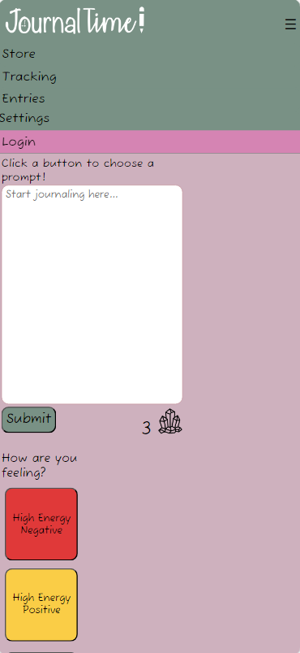
* I also added more product description pages for each shop item

Shayne -

* submit popup: I created a popup on the home screen page that appears when the submit button is clicked and shows that the user earned one crystal for the entry. I animated it with JavaScript to popup over the crystal count and then disappear after a second as shown in the GIF. The count of the crystals remains the same which is something that we will have to address in the future when the SQL database is connected.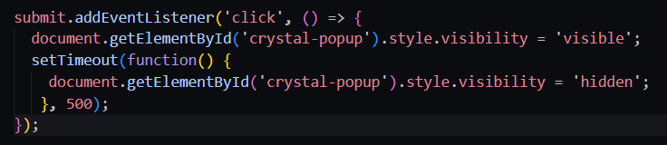
* prompt covers: I created covers for the different prompt packages that are an example of the prompts within that package. I just did this with a Google Drawing and text with a transparent background.
* tutorial for store (useless): I followed a tutorial on how to create an ecommerce website but it was mostly just the HTML of setting up the homepages and stuff that I already have and/or didn’t need. I wanted to see how they created the product pages for each product and what the most efficient way to do it would be, but the tutorial didn’t even really cover that. Overall, kind of a waste of time for me.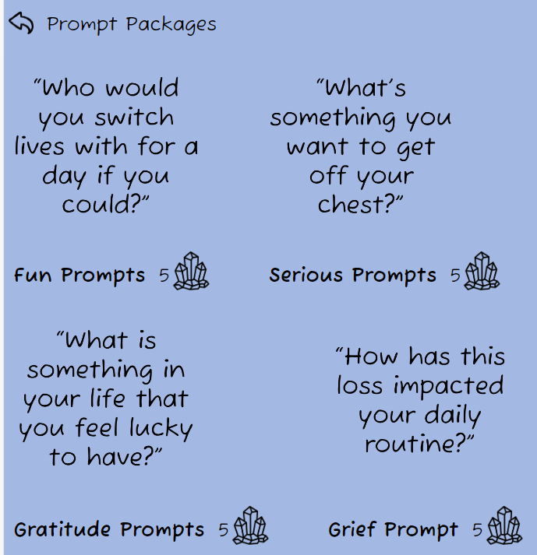
* product pages: To start working on the individual product pages I wireframes what I wanted them to look like in Adobe XD.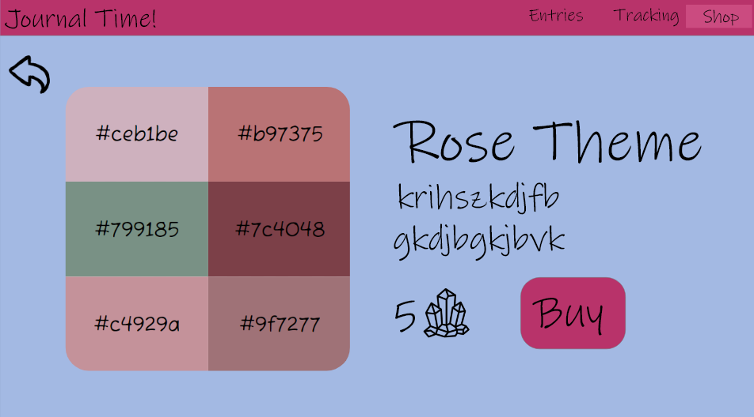I decided on creating separate sections for each product page and making them appear/disappear with JavaScript. I already had this function set up on the store page to hide or display the different category sections so it was easy to implement for this. One problem with using that method though is that the header for the store with the search bar is still on the product pages because I have them appear for the category pages. I wrote an if statement to get rid of the filtering and sorting buttons but for some reason it didn’t work for the search bar. I’m not sure why this is the case but I have to figure it out. I included pictures of the HTML section for one of the products, the JS function, and what the pages look like coded.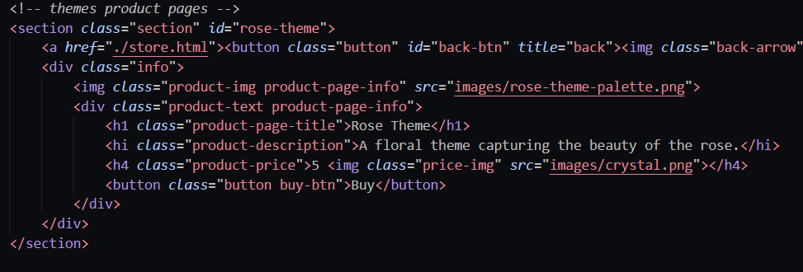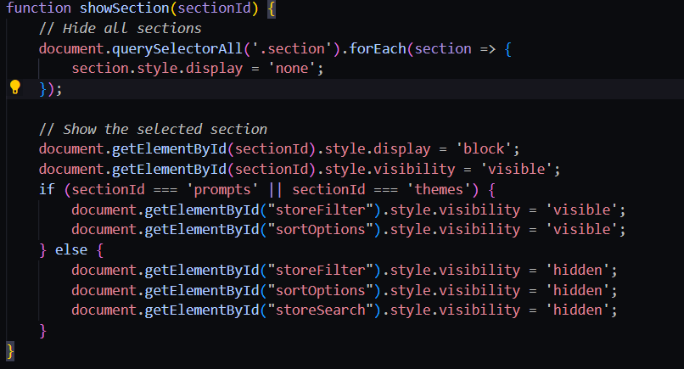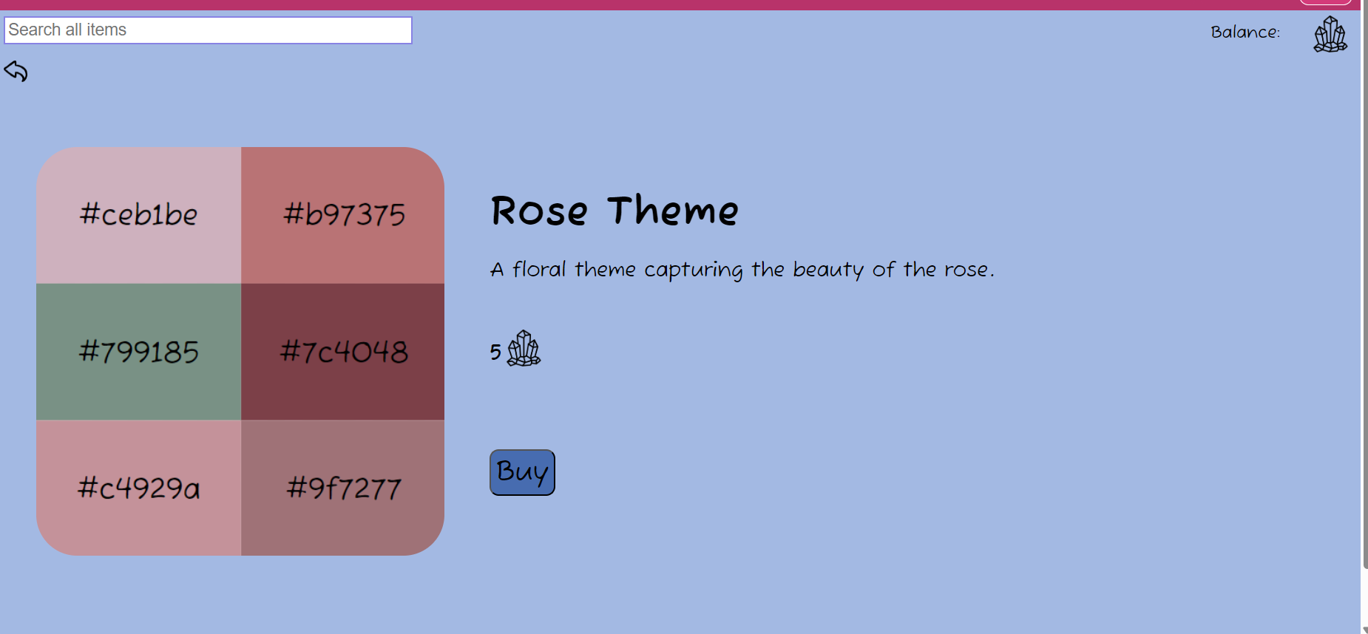

Ava -

* Codecademy course (PHP Skill Path)
  + practiced back-end data validation
  + integrating PHP into HTML forms
  + good practices for sanitizing data and protecting the security of a database
* Practiced writing PHP functions in Codecademy projects
* Began to write PHP to apply to Journal Time! database
* Added rewards info table to database

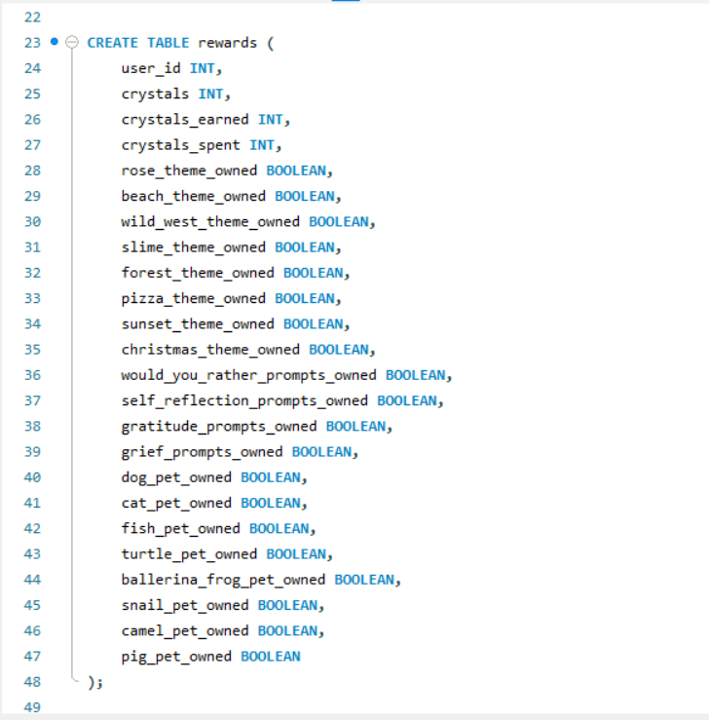

* Added email notification settings to database
* columns can be added in the future as needed, but I started with the essentials to keep it simple while we work things out

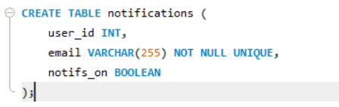

* looked into hosting the SQL server to keep the website functional 24/7

# **Difficulties Encountered this Progress Period**

We had a lot of issues with our styling this period. When Shayne would save changes made in a SCSS file, it would overwrite Laurens CSS code. We figured out that this was happening because the CSS stylesheet was updating automatically when the SCSS was saved and the things being overwritten were not present in the SCSS files so the CSS changed to match that. This was because Lauren was coding directly in the CSS stylesheet and the things there don’t automatically transfer to the SCSS. From now on we will both code in SCSS to avoid the overwriting. There were also a lot of other small and weird errors within the code. Some of these just required a hard reload and fixing mistakes to fix.

# **Updated Trello Board and Discussion**

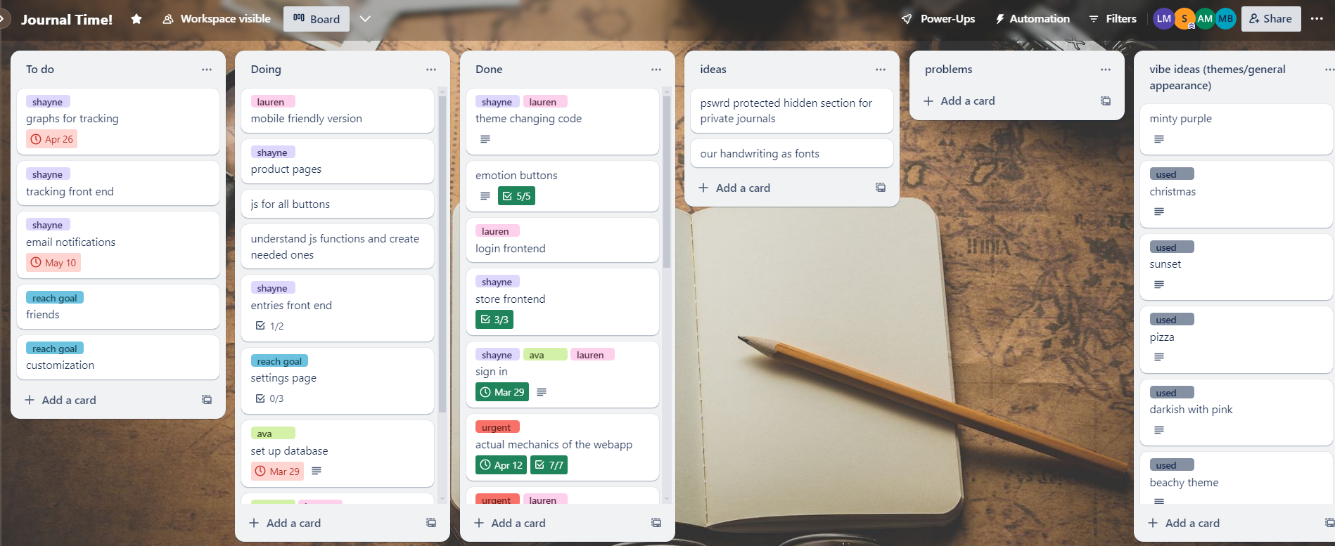

<https://trello.com/b/5P60HsFp>

# **Tasks to Be Worked on in Next Progress Period**

**Lauren** -

* connect login page with SQL database
* figure out rewards systems with SQL database/JS
* custom encouragement messages
* finish mobile friendly compatibility

Shayne -

* perfect store product pages and create them for all the products
* set up notification system

Ava -

* hosting SQL server
* finishing PHP to connect HTML form to database
* expanding the database to include rewards info, email settings, etc.

# **Additional Information**

The code was being weird this period and it required some time to work out the issues and fix them. Going forward things should run a lot smoother (fingers crossed). Again, the SQL database is required for the last few big things we aim to accomplish like actually making the journal entries save and be available to the user, so that is a top priority.